MammaKind
Safeguarding Policy

- Purpose
  - The purpose of this policy is to protect people, particularly children, vulnerable adults and other users of MammaKind’s services, from any harm that may be caused due to their coming into contact with MammaKind. This includes harm arising from:
    - The conduct of staff or personnel associated with MammaKind.
    - The design and implementation of MammaKind’s services.
  - It also seeks to protect MammaKind staff, volunteers and associated personnel from harm. The policy lays out the commitments made by us and informs staff and associated personnel of their responsibilities in relation to safeguarding.
  - Those who receive services provided by MammaKind are referred to in this Policy as its Service Users.

- Key Information
  - Any concerns relating to possible harm to anyone associated with MammaKind should be reported to one of the following Safeguarding Officers:

Kelly Fort | Chief Operating Officer | Email: kelly@mammakind.org.uk  Tel: 07983 509903
Katie Allen-East | Trustee | Email: ktkatjena@hotmail.com  Tel: 07837 139 106

- Commitment to safeguarding
  - MammaKind is committed to working in Service Users interests, to promote their welfare, and to put in place safeguards and measures to protect them. MammaKind will try at all times to minimise risk to Service Users and to ensure that they are as safe as possible.
  - MammaKind aims to protect its Service Users from any act or behaviour of any member of staff or volunteer which, whether deliberately or unknowingly, causes harm or ill treatment.
  - MammaKind also seeks to create a safe environment for staff and volunteers and will try to minimise the risk of harm or ill treatment to them.
  - Such harm or ill treatment includes abuse (physical, sexual, emotional, discriminatory, institutional or organisational, financial or material), neglect, or impairment of the health or development of invididuals associated with MammaKind.
  - MammaKind recognises that it has a duty to act on reports or suspicions of abuse or neglect. It has “zero-tolerance” for abuse.

- Awareness of harm and abuse
  - All incidents of harm will require an appropriate response to reduce risks and improve MammaKind’s services.
  - Harm is caused by accidents, deliberate abuse (physical, psychological, sexual, emotional, financial), neglect (deliberate or not) or factors such as bullying, prejudicial attitudes, or a failure to enable a person to participate in activities that are open to most of their peers. It can also include abuse via use of ICT facilities (e.g. grooming, bullying via the internet).
  - Deliberate acts of harm (physical, psychological, sexual, emotional and financial) and neglect are abuses against the person. Those acts will incur disciplinary proceedings and require reports and referrals to social services, the police, other professional bodies, and the DBS if the act is by someone in Regulated Activity. If a criminal offence is thought to have been committed by any staff member or volunteer, the police will be informed.

- Recruitment and training
  - Each new member of staff, and any volunteer who may have unsupervised direct contact with Service Users, is required to undergo a Disclosure & Barring Service (“DBS”) check – enhanced where appropriate - as part of our recruitment process.
  - At induction - each new member of staff or volunteer is made familiar with our policies and procedures, including safeguarding.
  - Safeguarding training is a requirement for all new staff and volunteers, with refreshers expected annually.

- Peer to peer interaction
  - Volunteers and staff will be encouraged to raise any issue that has caused them concern, in confidence, to the Session Lead, Chief Operating Officer or Safeguarding Trustee and to avoid disclosing sensitive issues to other volunteers/staff.
  - Addressing any safeguarding concerns will be led by the MammaKind leadership team. MammaKind leadership team will maintain a list of relevant local services that can be accessed by staff/volunteers if they need support.
  - MammaKind leadership team will continue learning through ongoing reflective practice and discussion of the issues raised.

- Confidentiality
  - All reports and logs (including personnel records) will be kept securely and confidentially according to MammaKind’s Privacy Policy or in line with the DBS Code of Practice for Registered Bodies if appropriate, until or unless it is necessary to share this material with the agencies named above, the Charity Commission or funders. Information will be shared by the Charity on a “need-to-know” basis only.

- Reports of possible or actual harm
  - MammaKind supports and encourages all Service Users, volunteers and staff to promptly speak up and contact the Safeguarding Officers where
    - there is a concern (i.e. a worry, issue or doubt about practice or about treatment of a Service User or colleague, or their circumstances), or
    - a disclosure (i.e. information about a person at risk of or suffering from Significant Harm), or
    - an allegation of an incident or a possibility that a volunteer or staff member has caused harm or could cause harm to a person in their care.
  - Staff or volunteers have a responsibility to report something that they become aware of if they suspect or discover that it is not right or is illegal or if it appears to them that someone at work is neglecting their duties, putting someone’s health and safety in danger or covering up wrongdoing. They may become aware of any of these things from what they see or hear or from something another person has disclosed to them.
  - MammaKind cannot promise confidentiality to staff or volunteers making an internal report where it is has to be shared with any statutory agencies.
  - MammaKind also supports its staff or volunteers to raise concerns or to disclose information, which they believe shows malpractice - whistle-blowing (disclosure in the public interest).

- How to respond to a disclosure
  - If a service user (adult or child) begins making a disclosure of harm to a staff member or volunteer, they can respond as follows:
        - Show you care – give them your full attention, keep your body language open, be compassionate and reassure them their concerns are important.
        - Take your time – respect pauses and don’t interrupt.
        - Show you understand – reflect back what they’ve said to you to check your understanding. Reassure them they’ve done the right thing in telling you.
        - Explain next steps – tell them you will need to share the information with MammaKind’s safeguarding officer, but with no one unnecessarily and that they will be informed of any further actions. Never inform the alleged perpetrator.
  - If staff or volunteers are made aware of or witness a situation where there is a serious and immediate threat to a service user, they should call 999 first and foremost.

- How to report a concern
  - Concerns and disclosures should be reported to one of the following Safeguarding Officers in person, or via the contact details noted:

Kelly Fort | Chief Operating Officer | Email: kelly@mammakind.org.uk  Tel: 07983 509903
Katie Allen-East | Trustee | Email: ktkatjena@hotmail.com  Tel: 07837 139 106

- Safeguarding Officers action
Where there is risk of Significant Harm to any Service User, volunteers or staff and the Safeguarding Officers have the power to act as necessary and, in particular, as follows:

- log all conversations regarding the issue in writing
- confidentially seek advice from expert sources
- share concerns (with consent where required and appropriate) internally with senior staff / Chair of the Board of trustees
- share concerns and make referrals to external agencies such as social services / local authorities (outlined below) or the police
- make a referral to the DBS regarding staff or volunteers in Regulated Activity whose conduct is harmful to Service Users and refer them to DBS when they are removed from Regulated Activity
- inform the Charity Commission when any safeguarding concern has resulted in or could have resulted in harm
- possibly inform funders where required.

- Local authorities
  - If concerns are raised to the safeguarding officers about service users, they may seek advice from or refer to the following local authority services:
    - Royal Greenwich Safeguarding Adults Board: 0208 921 2304/ 0208 854 8888 (out of hours); AOPS.Contact.Officers@royalgreenwich.gov.uk
    - Greenwich Multi-Agency Safeguarding Hub (MASH): 020 8921 3172 / 020 8854 8888 (out of hours); mash-referrals@royalgreenwich.gov.uk. Consultation line for professionals: 020 8921 2267. Their referral form can be downloaded here.
    - Lewisham Adult Social Care: 0208 314 7777; gateway@lewisham.gov.uk
    - Lewisham Multi-Agency Safeguarding Hub (MASH): 020 8314 6660; mashagency@lewisham.gov.uk. Referrals can be made online here.

  - Before making any referrals to children’s social services, the safeguarding officers will:
    - Review the local authority threshholds of need and be clear about why they think concerns have reached a certain threshold.
    - Discuss the concern with colleagues and possibly other known professionals, and obtain their perspectives and any additional information.
    - Discuss the concern with the family and/or child, unless they believe that to do so would endanger the child, or someone else.

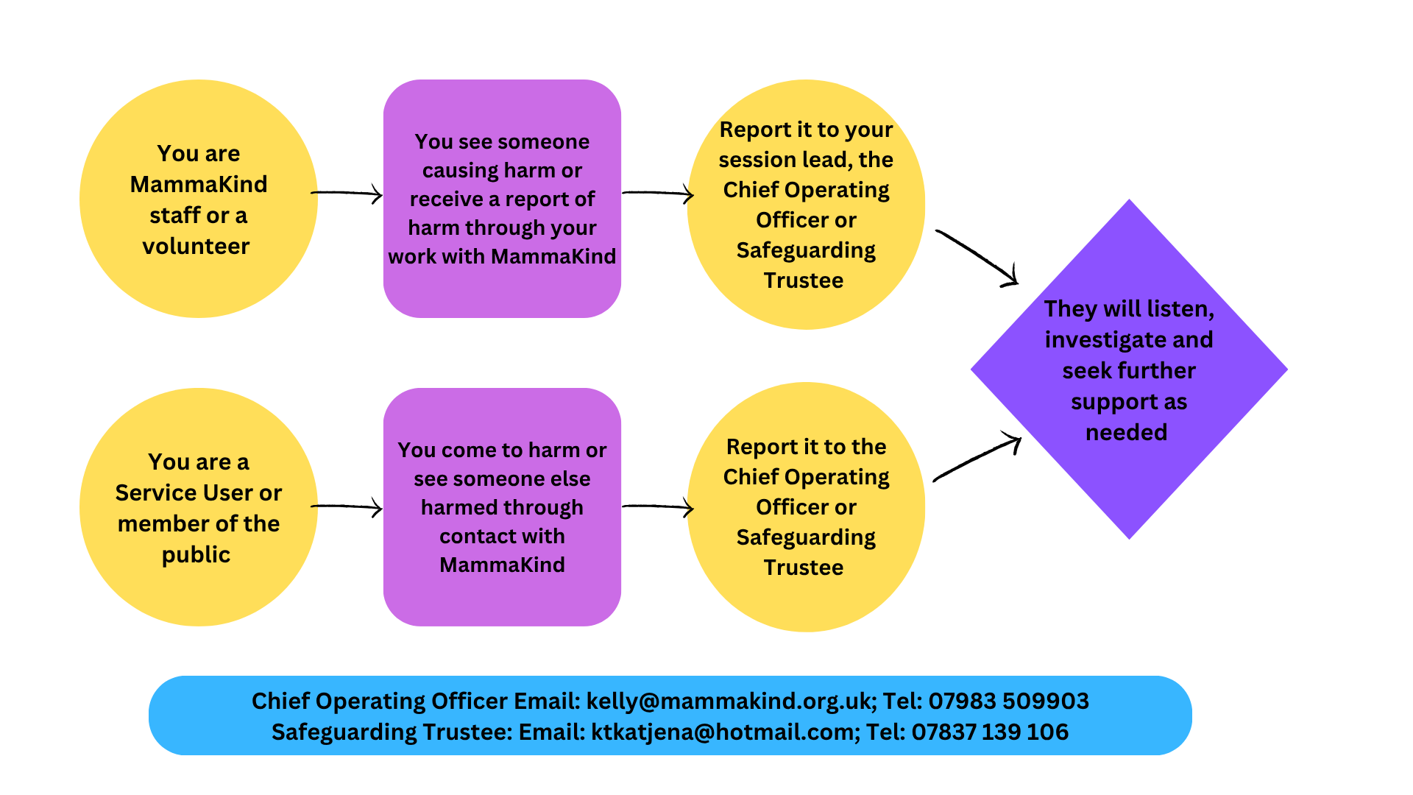

- Implementation of this Policy
  - This Policy must be followed by all staff and volunteers of MammaKind and promoted by all trustees and senior staff. Failure to follow it will be treated as a serious matter.
  - This Policy needs to be read in conjunction with the following policies and procedures of the Charity:
Health & Safety Policy
Privacy Policy
Equal Opportunities Policy

Change Control

Version No. | Revision Comments | Author / Editor | Issue Date
1.0 | Initial draft policy | Kirsty Lowe | 10/02/2021
2.0 | Approved policy | Katie Allen-East / Kirsty Lowe | 03/04/2021
3.0 | Additional sections | Katie Allen-East | 04/01/2022
4.0 | Policy review – local authority safeguarding contact details updated | Kirsty Lowe | 23/03/2023
5.0 | Policy review – accessibility improvements | Katie Allen-East  Kirsty Lowe | 19/03/2024
6.0 | Approved policy | Kirsty Lowe  Katie Allen-East | 22/04/2025
7.0 | Policy review – additional information on referrals added | Katie Allen-East | 22/04/2026
8.0 | Approved policy | Kirsty Lowe | 29/04/2026

